**Specification of the prototype of indoor air quality meter**

|  |  |
| --- | --- |
| **GTC INTERNAL CODE:** |  |
| **DEPARTMENT :** | Sensors for Application and Processes |

|  |  |
| --- | --- |
| **DOCUMENT NUMBER:** | v02 |

|  |  |
| --- | --- |
| **AUTHORS:** | Andrei Golovin |
|  |  |
|  |  |
|  |  |

|  |  |  |
| --- | --- | --- |
| **DISTRIBUTION LIST:** | **NAME** | **COMPANY (ELECTROLUX UNIT)** |
|  |  |  |
|  |  |  |
|  |  |  |
|  |  |  |
|  |  |  |
|  |  |  |
|  |  |  |
|  |  |  |
|  |  |  |

|  |  |  |  |
| --- | --- | --- | --- |
|  | **DATE** | **NAME** | **POSITION** |
| **ISSUED** |  | Andrei Golovin | Activity Leader |
| **CHECKED** |  | Michele Toppano | Line Manager |

1. **Sensor part**

The list of sensors to be used:

|  |  |  |  |
| --- | --- | --- | --- |
| **Parameter** | **Sensor** | **Manufacturer** | **Description** |
| Temperature | Si7013 | Silicon Labs | Capacitive humidity sensor with I2C interface |
| Relative humidity | Si7013 | Silicon Labs |
| PM2.5/10 | SDS021 | Nova Fitness | Optical laser diode-based sensor with UART interface |
| VOCs | MiCS-5524 *1 | SGX Sensortech | Analog MOX-based resistive sensor |
| CO2 | Cozir Ambient | Gas sensing solutions | NDIR-based sensor with UART interface |
| Ambient light | TSL2561T *2 | AMS | Light sensor with I2C interface |
| Noise | SPM0404HE5H-T *3 | Knowles | MEMS microphone with electronics developed by GTC |

Comments:

1. Sensor signal isn't calibrated. The readings in arbitrary units are proportional to the total level of VOCs.
2. Sensor signal isn't calibrated. The readings in arbitrary units are proportional to the lighting level on the sensor sensitive surface.
3. Sensor signal isn't calibrated. The readings in arbitrary units are proportional to an average noise level in space around the microphone.
4. **Hardware**

The core part of hardware is an Arduino MCU board. The MCU processes all signals from sensors. Also the board has a WiFi module which allows setting TCP connection between the board and PC.

Hardware includes also parts:

* to provide power supply to all components
* to build buses which are used (I2C, UART)
* to maintain signal conditioning where needed (VOC sensor)

1. **Firmware**

MCU firmware allows:

* send request to sensors to extract readings
* average data if needed
* run TCP server

1. **Protocol**

TCP protocol over WiFi connection is used. The Arduino board works in the wireless access point mode. PC or tablet with Windows OS should be connected to wireless lan created by the Arduino board. Readings of all sensors are joined to one string with a specified format. If a TCP client exists the TCP server on the Arduino board will send the string with readings with specified time interval to the client. An example of the string format (could be changed if needed):

VOC 2.44 T 23.5 RH 43.7 CO2 988 PM25 4.5 PM10 7.2 L 120 N 10

Where

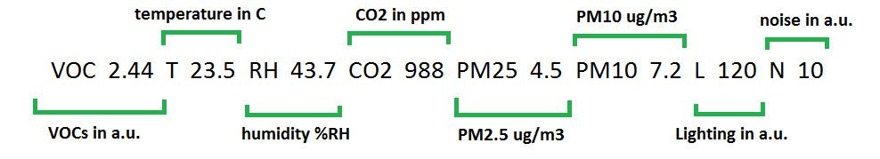

Please, note when PC goes to sleep/hibernation mode or switching user Windows closes all TCP clients. It means if you use GTC app to log data PC or tablet must be in the active mode.

1. **Ventilation**

The prototype will include a small fan (~ 40x40mm) which allows ventilating the space around sensors. The fan could be powered on by button or from app as you prefer.

1. **Power supply**

The prototype requires an external 5V power supply.

1. **Housing box**

All sensors and electronics will be assembled in GTC in Porcia. In order to mount all parts to a housing box the following options can be considered:

* the box developed by Air Care should be delivered to Porcia to mount all stuff
* assembled sensors and electronics can be delivered to Stockholm as it is
* the box can be developed by GTC

A minimal space needed to place all stuff is about 100x100x100mm

1. **Application**

Windows app can be delivered if needed. The app allows to set TCP connections, display sensor readings and log sensor readings to text file.